**INFO1131 - Lab 4**

Recreate the following one page layout. Feel free to use the starting html file or create your own.

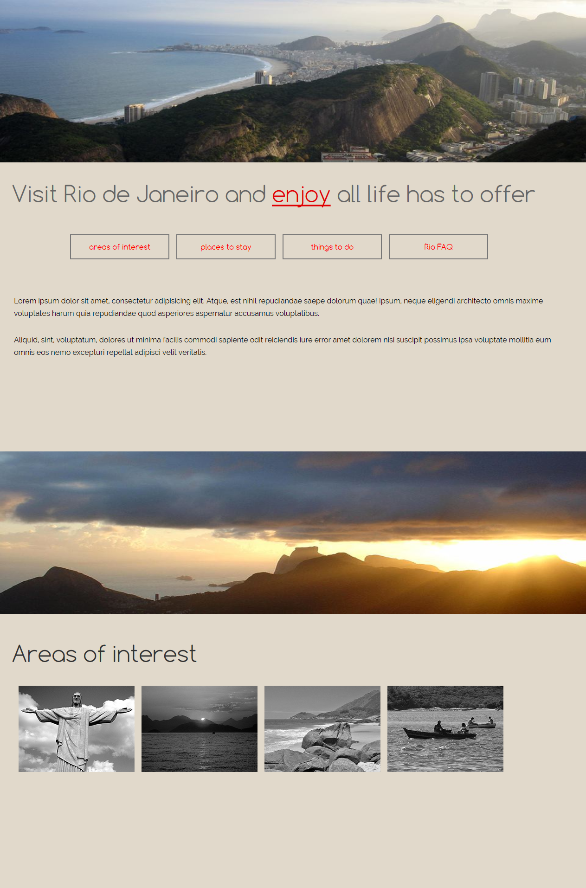

**Details:**

* The page is divided up into 2 sections.
* Both have a header image that scales to fit the browser width. There is a max-height of 350px on both to control the amount of space it takes up in the browser.
* For the h1s and the nav links the google font used is Comfortaa. For the paragraph text the font used is Raleway. You may choose different fonts.
* The body background color used is #E1D9CB - feel free to use whatever color you like
* The areas of interest link in the nav links to the areas of interest section of the page
* The navigation features a rollover with a transition. Create your own effect or copy the rollover effect created below

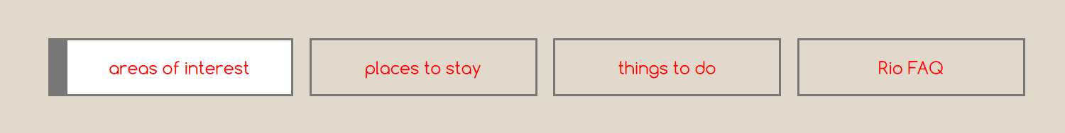

* For the gallery of images, the pictures were placed in an unordered list with li floated to the left. You may set yours up any way you want. The images rollover on the hover to display a color version. I used a transform: translateY to slide the images up on the hover and applied a transition to smooth it out over time.

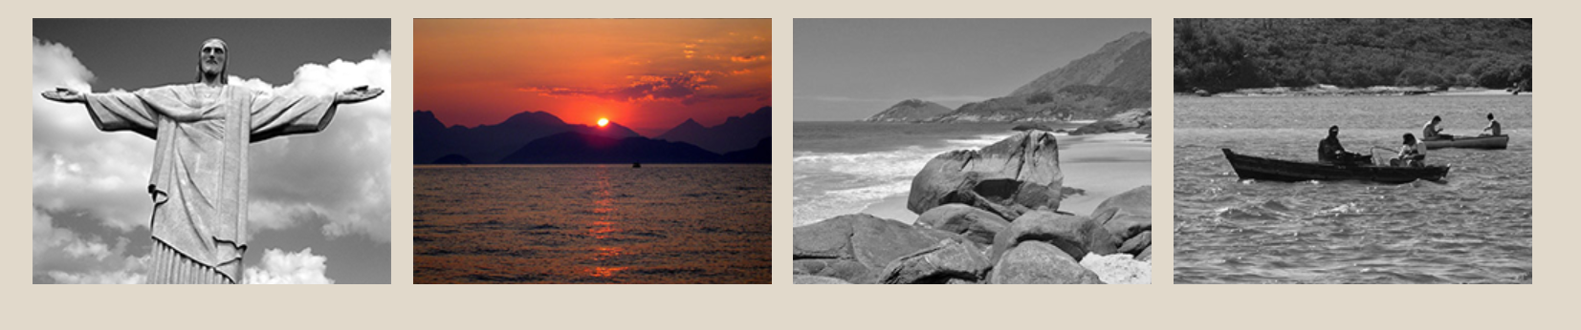

* You will have to create the gallery images in Photoshop. I have provided the color versions. You will have to increase the canvas size and copy the image. Take the layer with the copied image and apply a black and white adjustment. See example pic below. Use half the height to apply to your translate (see example we did in the one hour class)

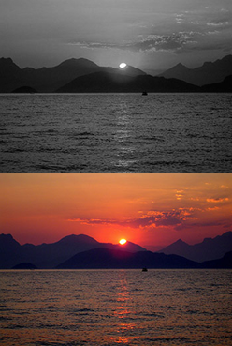

**Create the responsive layout for 700px or smaller.**

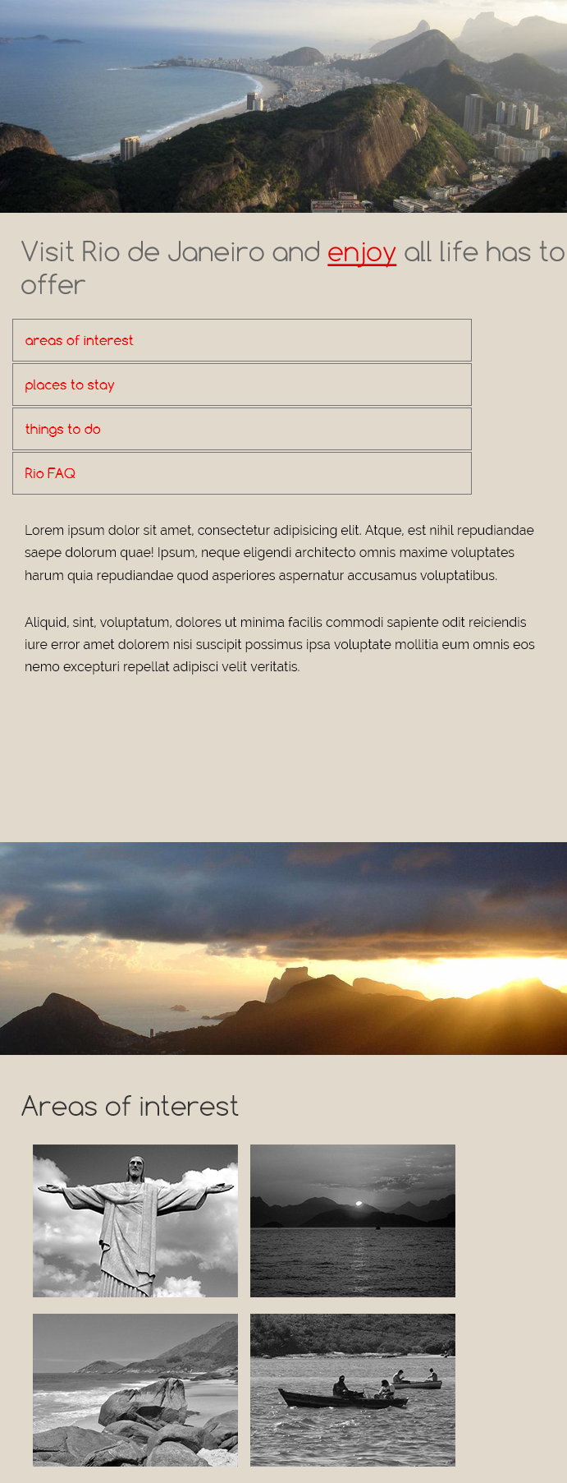

* The only changes made were to the nav - displayed in block format and not floating to the left
* Reducing the size of the h1s
* Adjusting the margins on the gallery of images

**Marks given for:**

* Header images
* Nav with rollover and transition
* H1 styling
* Google fonts
* Gallery of images with rollover effect and transition
* Setup of gallery images in Photoshop
* Responsive layout

Submit all files, including Photoshop files zipped to the lab 4 dropbox by 5pm January 5.